**Neha Malhotra**  **R.L. Institute M: 9416974837**

**Max Time : 1 hr** **Class = 12th Biology Test**  **Max Marks : 20**

**PRINCIPLES OF INHERITANCE & VARIATION – 2**

1. Multiple choice questions : [ 1 X 5 = 5]
2. Condition of a karyotype 2n + 1 , 2n –1 and 2n + 2 , 2n –2 are called

|  |  |  |  |
| --- | --- | --- | --- |
| a) Aneuploidy | b) Polyploidy | c) Allopolyploidy | d) Monosomy |

1. Which of the following will not result in variations among siblings?

|  |  |
| --- | --- |
| a) Independent assortment of genes | b) Crossing over |
| c) Linkage | d) Mutation |

1. ZZ/ZW type of sex determination is seen in

|  |  |  |  |
| --- | --- | --- | --- |
| a) Platypus | b) Snails | c) Cockroach | d) Peacock |

1. Occasionally, a single gene may express more than one effect. The phenomenon is called

|  |  |  |  |
| --- | --- | --- | --- |
| a) Multiple allelism | b) Mosaicism | c) Pleiotropy | d) Polygeny |

1. Which of the following represents a pair of contrasting traits

|  |  |  |  |
| --- | --- | --- | --- |
| a) Alleles | b) Phenotype | c) Homozygous | d) Heterozygous |

1. In the given figure which of the following gene pair will show more recombination frequency? Give reason in support of your answer. [ 2 ]

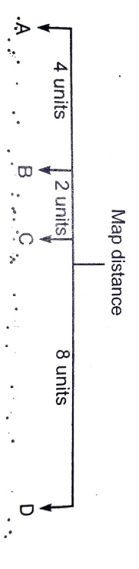

1. Study the figure given below and answer the question. [ 2 ]

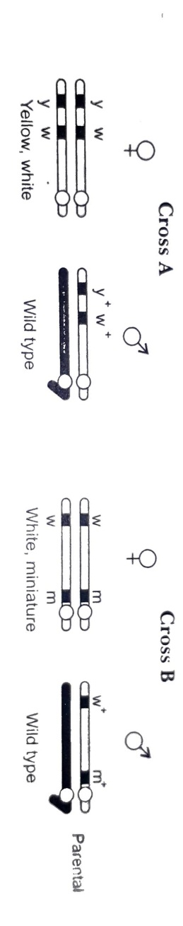

Identify in which of the following crosses is the strength of linkage between the genes higher. give reason.

1. Name a human genetic disorder due to following : [ 2 ]

(i) An addition of X-chromosome in a male

(ii) Deletion of one X-chromosome in a female

1. Mention any two genetic disorders with their symptoms. [ 3 ]
2. Write the scientific name of fruit fly. Why did Morgan prefer to work on fruit fly. State any 3 reasons. [ 3 ]
3. Differentiate between ‘ZZ’ and ‘XY’ type of sex determination mechanism. [ 3 ]